Data Analysis and Algorithm

Practical 2-b

Compare Insertion sort and Merge sort Algorithms

Name – Yash Vasudeo Prajapati

Rollno - 022

MSc. Computer Science

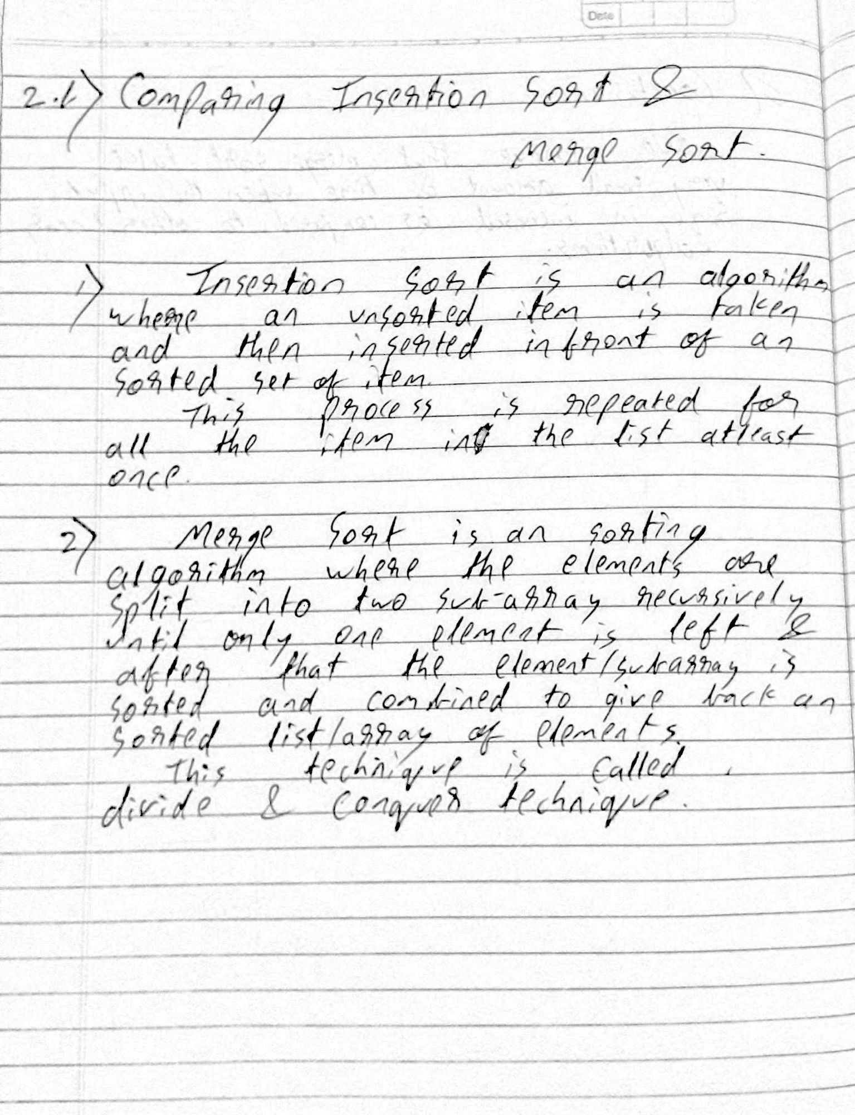

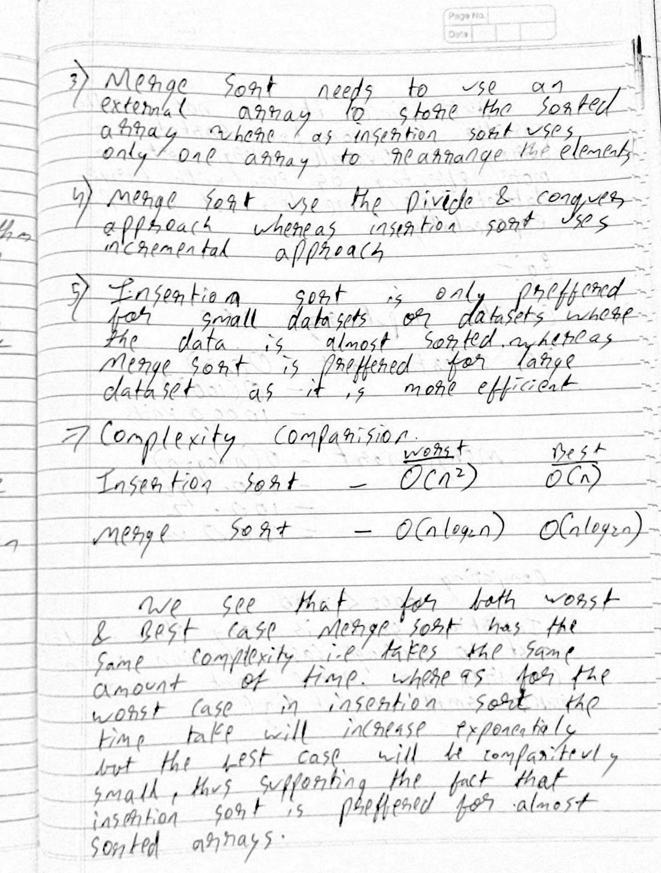

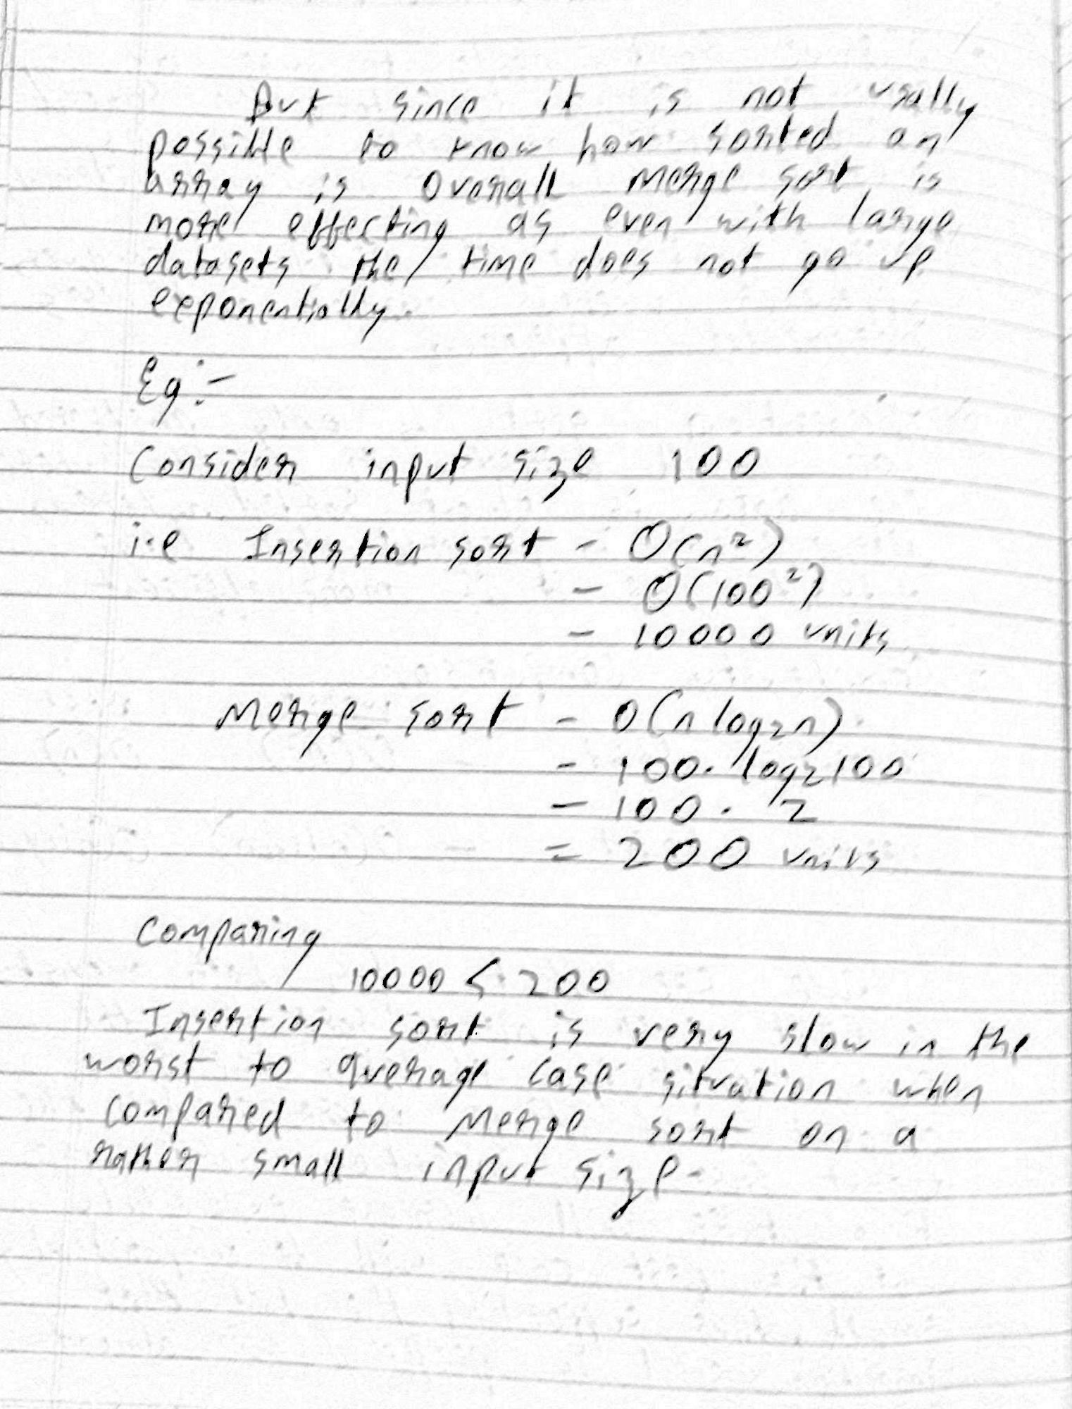

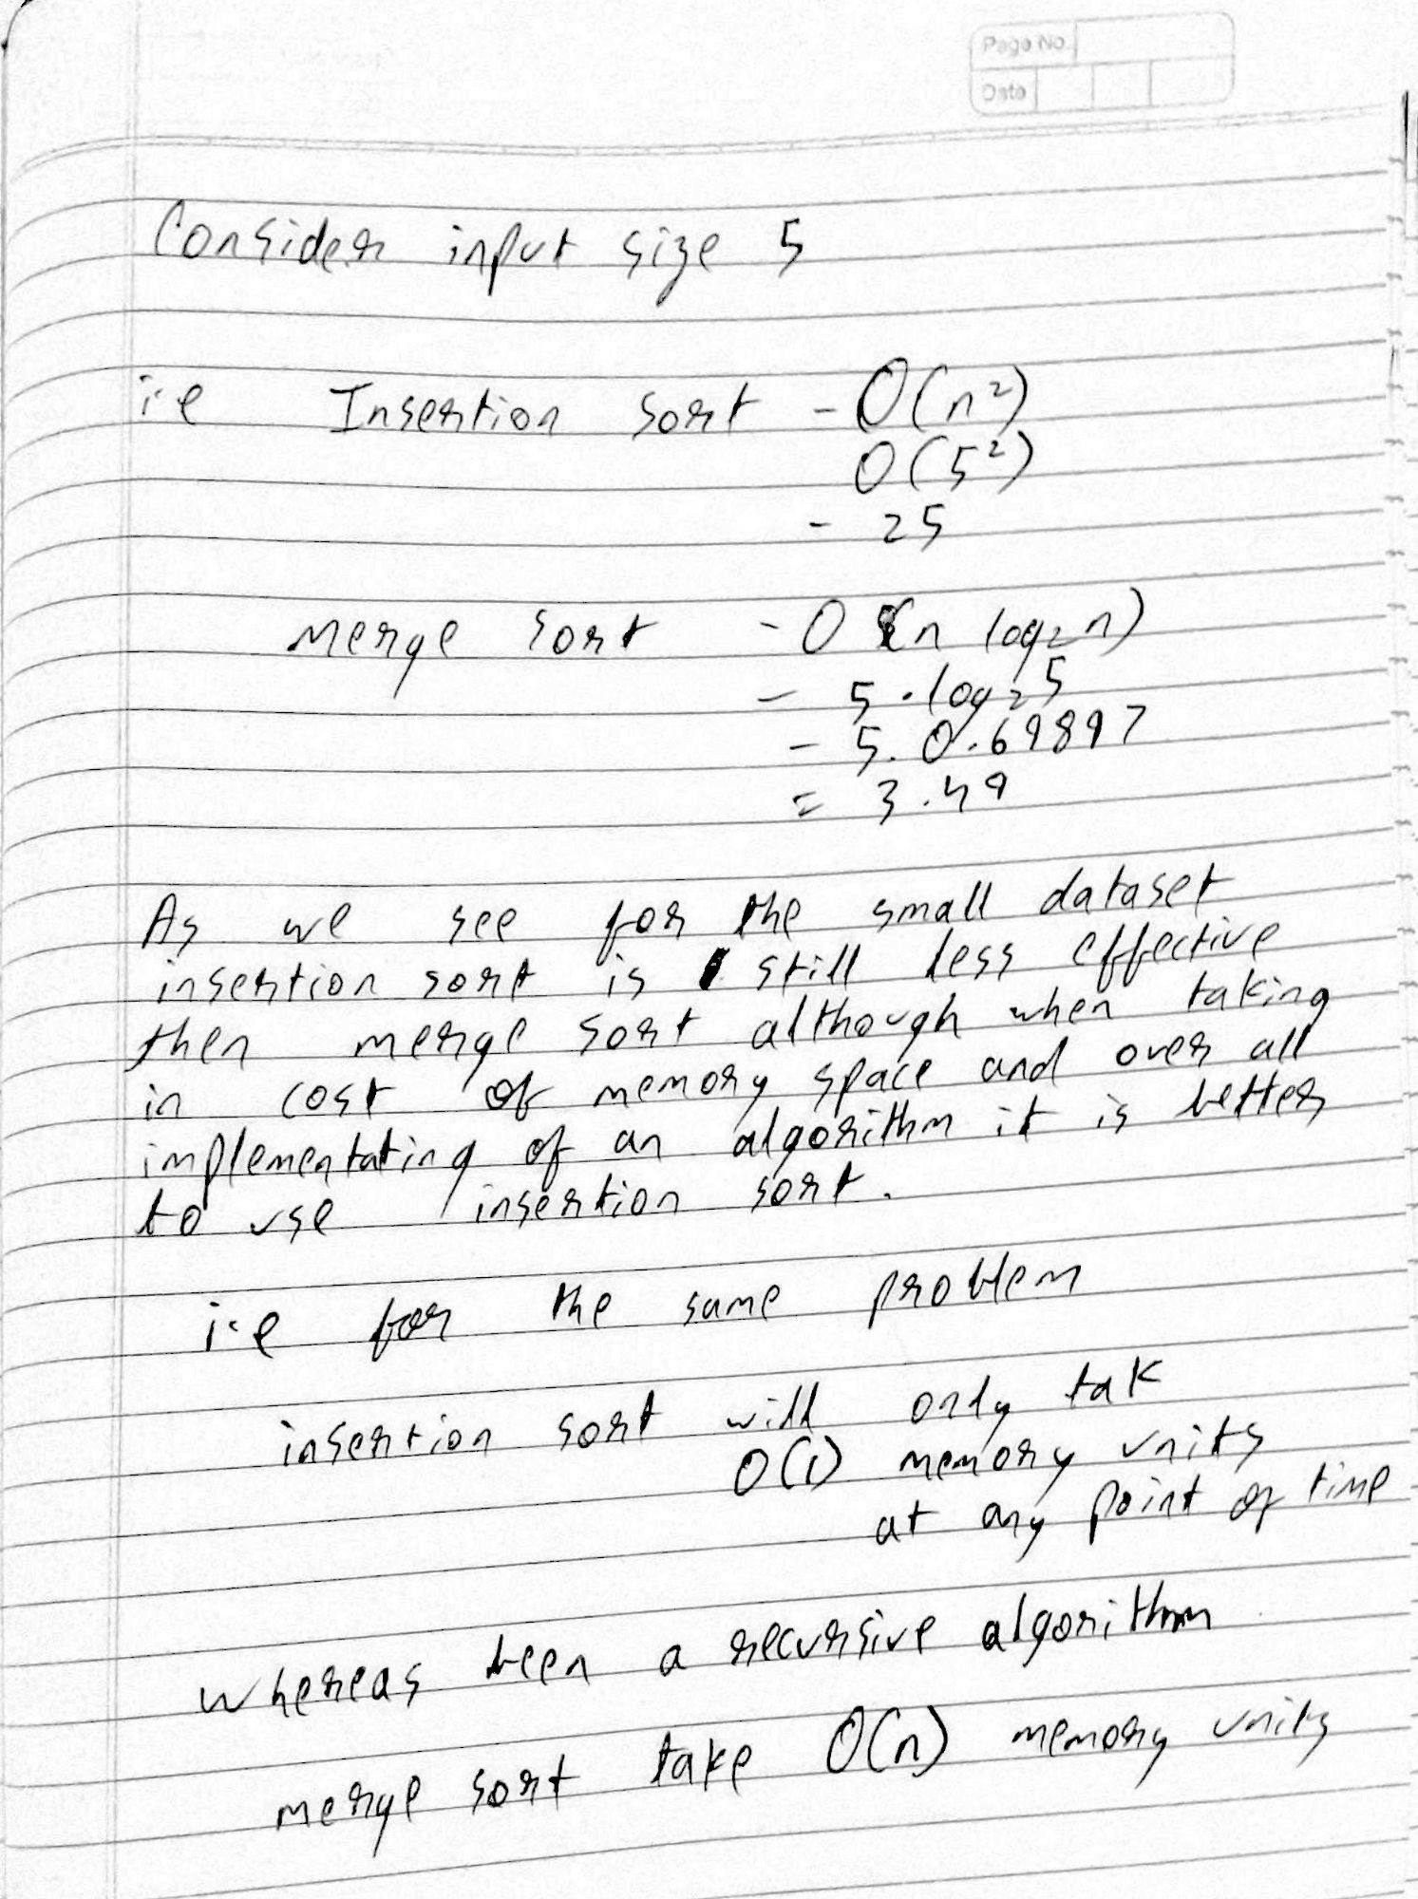

Comparing the two algorithm run time

1. import matplotlib.pyplot as plt
2. import numpy as np
3. from insertionsort import insertion_sort
4. from mergesort import mergeSort,merge
5. import timeit
6. import random
8. SETUP_CODE = '''
9. from __main__ import insertion_sort
10. import random
11. '''
12. x = [0, 100 , 200 , 400 ,800]
13. y = []
14. y1 = []
15. #0 run test by changing the upper range of for loop with values in x
16. TEST_CODE = '''
17. arr=[]
18. for i in range (1,0):
19. n = random.randint(0,100)
20. arr.append(n)
21. insertion_sort(arr)'''
23. times = timeit.timeit(setup = SETUP_CODE,
24. stmt = TEST_CODE,
25. number = 1)
26. y.append(times)

29. SETUP_CODE = '''
30. from __main__ import mergeSort,merge
31. import random
32. '''
34. #0 run test by changing the upper range of for loop with values in x
35. TEST_CODE = '''
36. arr=[]
37. for i in range (1,0):
38. n = random.randint(0,100)
39. arr.append(n)
40. mergeSort(arr, 0, len(arr)-1)'''
42. times = timeit.timeit(setup = SETUP_CODE,
43. stmt = TEST_CODE,
44. number = 1)
45. y1.append(times)
47. print(y)
48. print(y1)
49. # plot graphs
50. plt.plot(x, y, label="Insertion sort n^2")
51. plt.plot(x, y1, label="Merge sort n.log n")
53. plt.xlabel("Input size")
54. plt.ylabel("Time taken")
55. plt.title('Comparing Insertion and merge plot')
56. plt.legend()
57. plt.show()

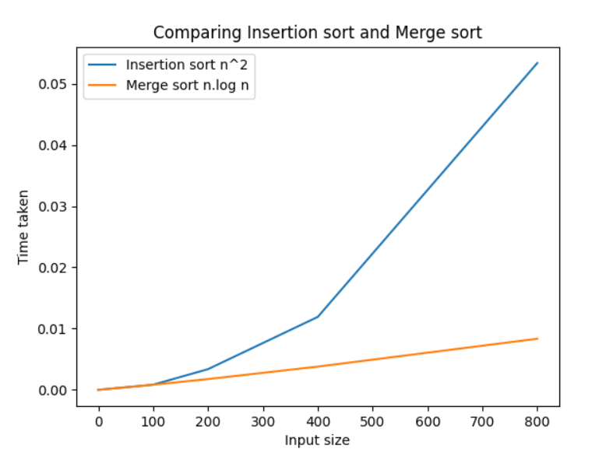

Plotting with worst case for both the sorting algorithms

1. import matplotlib.pyplot as plt
2. import numpy as np
3. import math
5. x = [ 0, 5, 10, 15, 20]
6. y=[0]
7. y1=[0]
8. for i in x:
9. if i== 0:
10. continue
11. n = i*i
12. y.append(n)
13. z = i*(math.log(i,2))
14. y1.append(z)

17. print(y)
18. print(y1)
19. plt.plot(x, y, label="Insertion sort n^2")
20. plt.plot(x, y1, label="Merge sort n.log n")
22. plt.xlabel("Input size")
23. plt.ylabel("Time taken")
24. plt.title('Comparing Insertion sort and Merge sort')
25. plt.legend()
26. plt.show()

